# Web Technologies

## Assignment-7

For this assignment, I have created a test website <https://abhinay-cookies.000webhostapp.com/> .

For the first-time users:

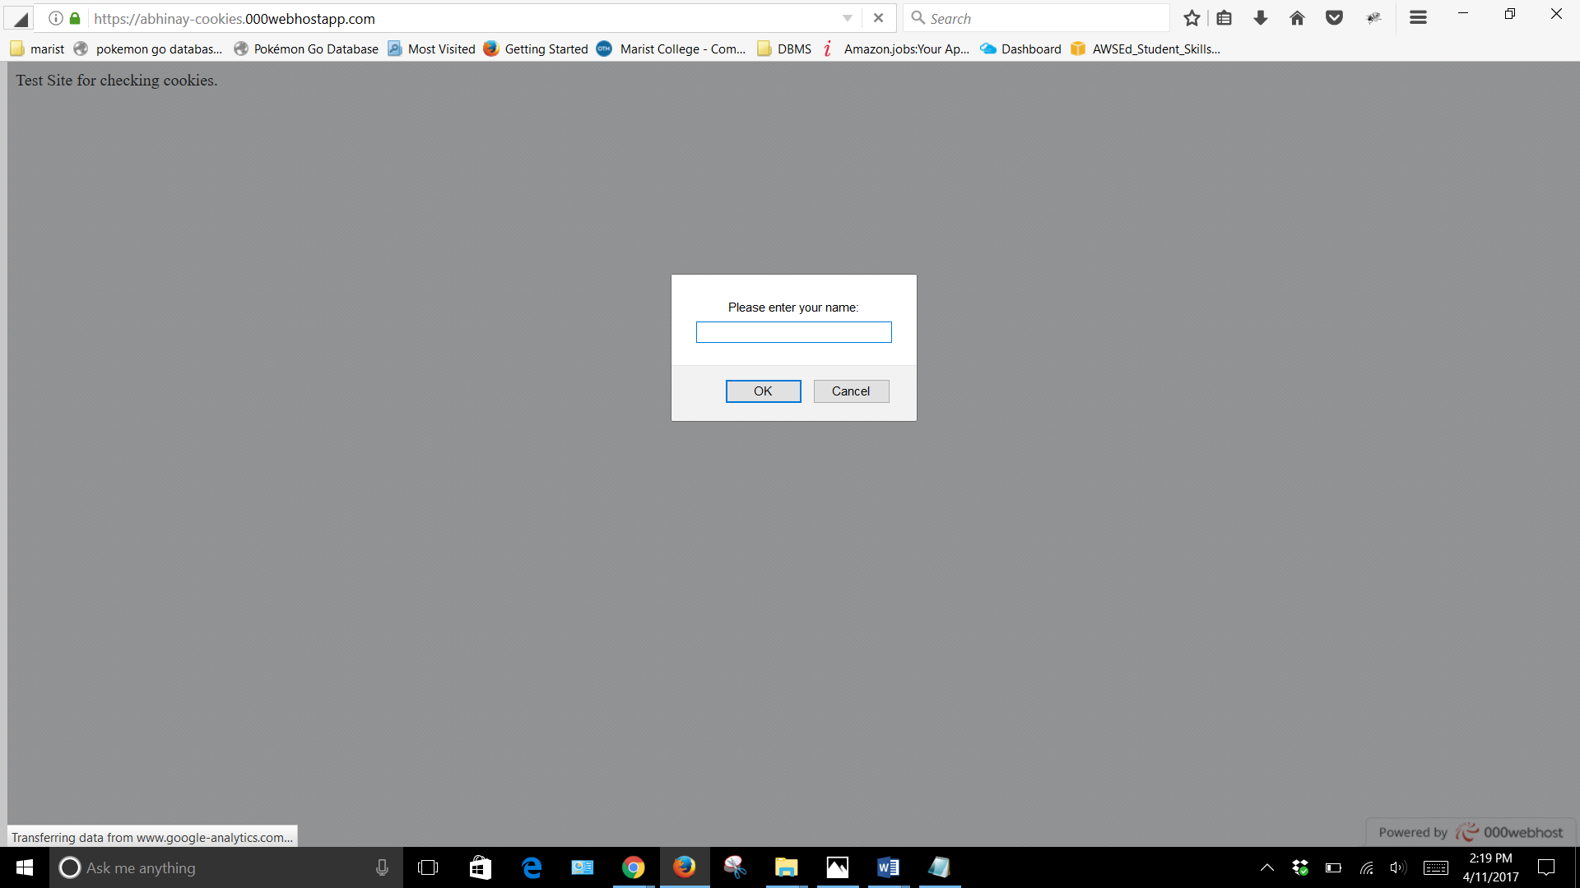

This was tested in Firefox.

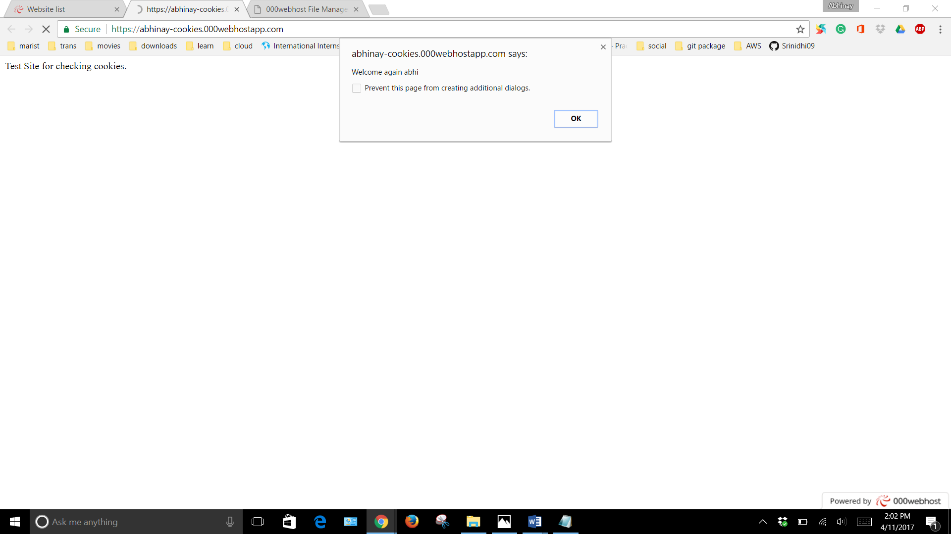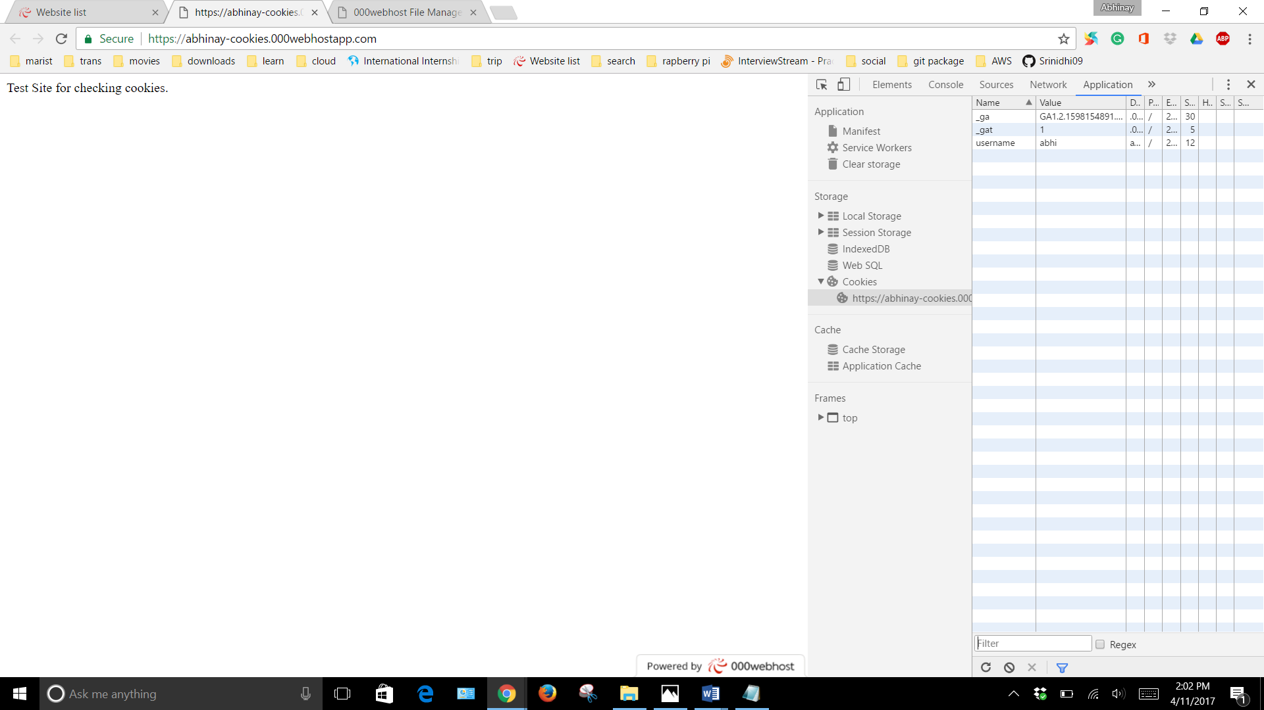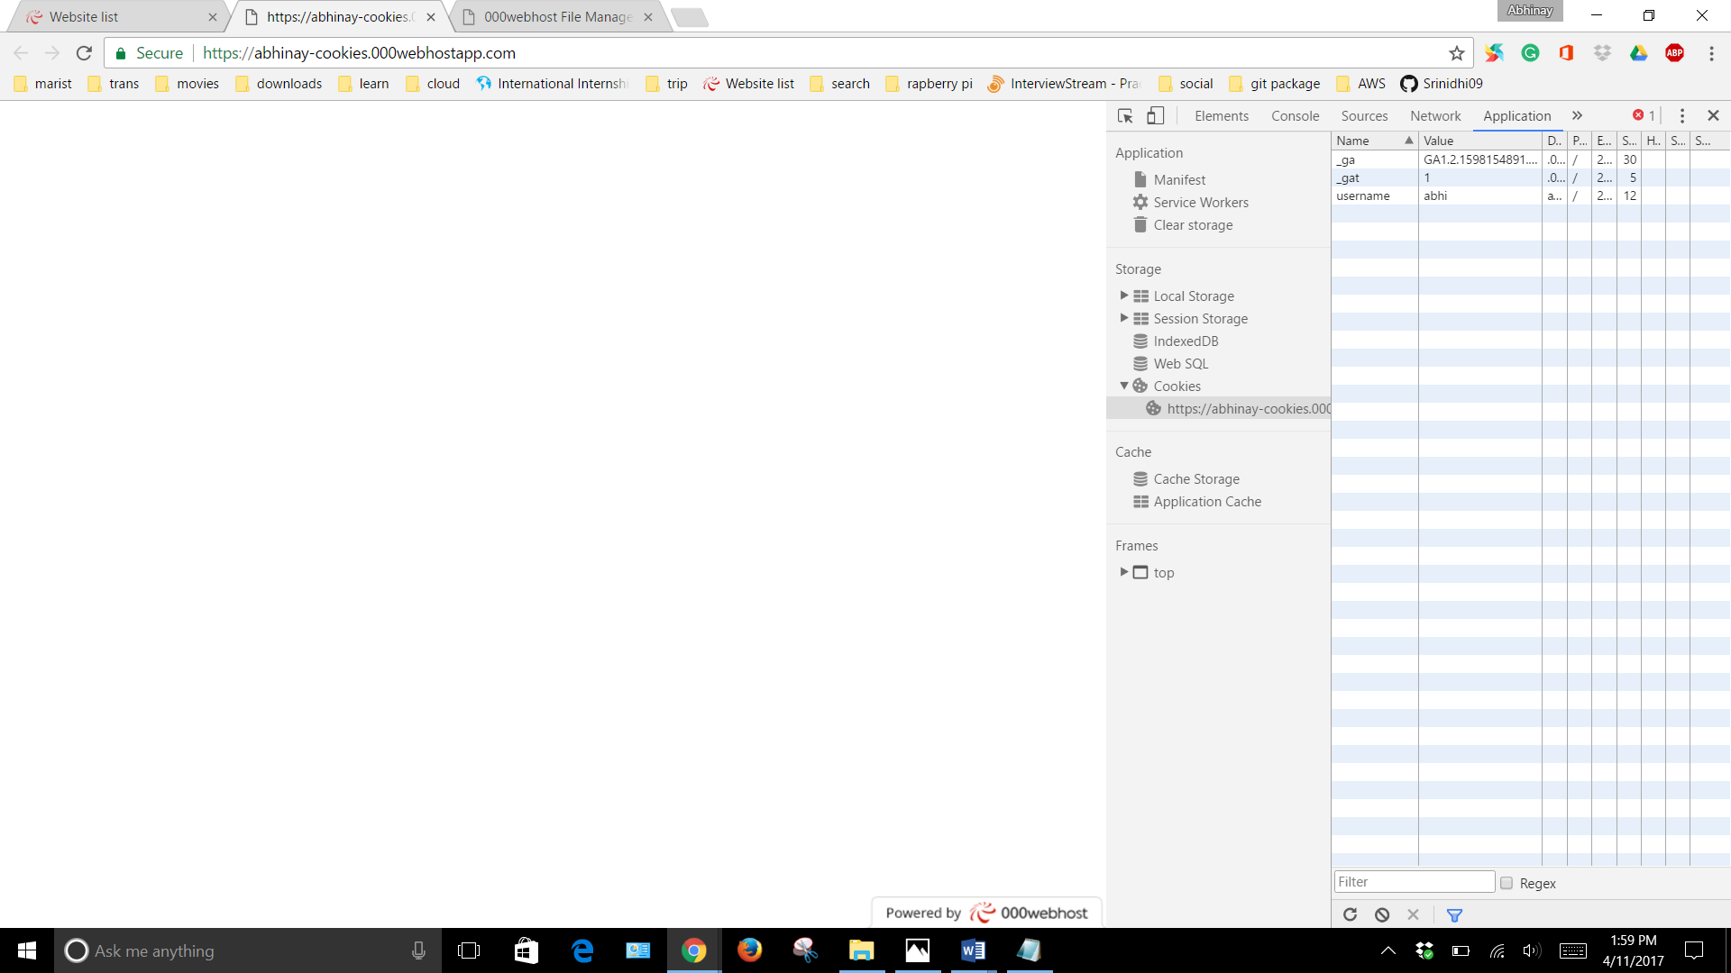

These are tested in Chrome.